

**A project Report on**

**AMAZON WEBSITE USING AUTOMATION TOOL SELENIUM WEBDRIVER WITH JAVA.**

**By**

**Anugangadevi Srinivasan**

**Batch-Software Testing (2021-5533)**

**Under the Guidance of,**

**Amruta Deore**

**(Technical Trainer)**

**EduBridge India Pvt. Ltd.**

**Introduction:**

This Project aims to do overall testing like functional testing, GUI testing on Amazon website to check quality of application using selenium web driver. It helps to improve quality of website and saves time for manually doing this testing.

Amazon.com is a vast Internet-based enterprise that sells books, music, movies, housewares, electronics, toys, and many other goods, either directly or as the middleman between other retailers and Amazon. com’s millions of customers.

**Software Requirements:**

Operating System: Windows 10

Browser: Latest version of Google Chrome

Platform: Eclipse IDE

Automation Tool and Language: Selenium WebDriver, Java

Files: JDK, Selenium Jar files, Common IO file

**1.AMAZON MODULE**

**TC01:** Launch the browser and Amazon website

**Selenium WebDriver Test Script:**

WebDriver driver = **new**ChromeDriver();

driver.manage().window().maximize();

driver.get("http://www.amazon.in/");

driver.manage().window().maximize();

System.***out***.println("Amazon Webpage Opened Successfully");

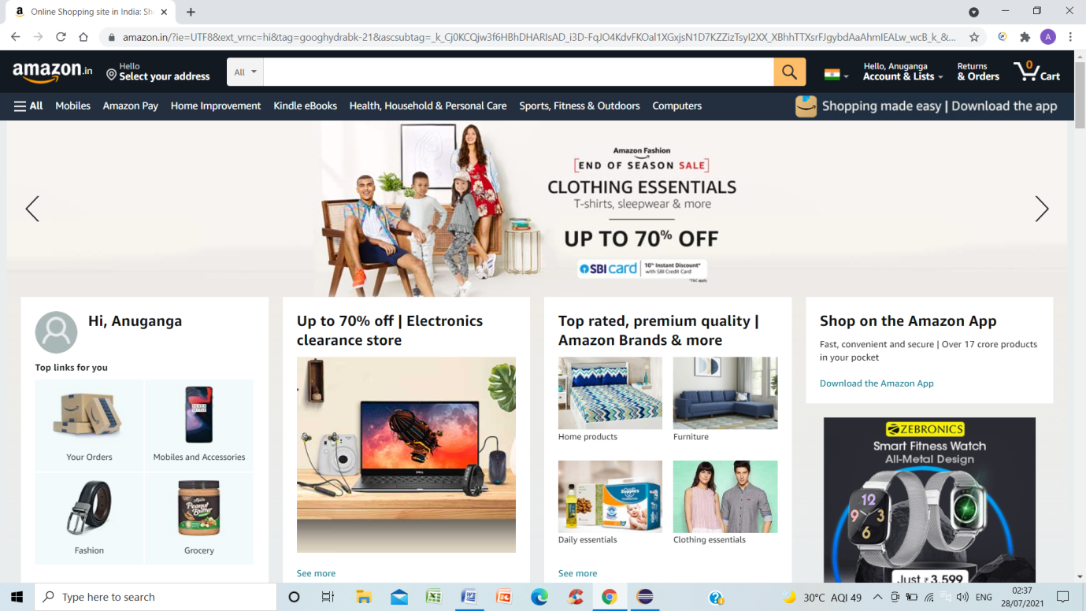

**TC02:** To verify the functionality of Login Button

**Selenium WebDriver Test Script:**

WebElement element = driver.findElement(By.*xpath*("//a[@id='nav-link accountList']")) ;

Actions act = **new** Actions(driver);

act.moveToElement(element).build().perform(); Thread.*sleep*(5000);

System.***out***.println("Mouse Over Done for Accounts & Lists");

driver.findElement(By.*xpath*("//header/div[@id='navbar']/div[@id='nav-flyout-anchor']/div[@id='nav-flyout-accountList']/div[2]/div[1]/div[1]/div[1]/a[1]/span[1]")).click();

driver.findElement(By.*name*("email")).sendKeys("anugangadevi1612@gmail.com");

driver.findElement(By.*id*("continue")).click();

driver.findElement(By.*name*("password")).sendKeys("Sweety@16");

driver.findElement(By.*id*("signInSubmit")).click();

System.***out***.println("Signed in successfully");

**TC03:** To verify and display the URL of Current page of browser.

**Selenium WebDriver Test Script:**

d.getCurrentUrl();

System.***out***.println("Current URL IS:" + d.getCurrentUrl());

**TC04:** To verify and display the Icon of the current page.

**Selenium WebDriver Test Script:**

driver.findElement(By.*id*("nav-logo-sprites"));

System.***out***.println("Icon displayed");

**TC05:** To verify the functionality of scroll up and scroll down of current page.

**Selenium WebDriver Test Script:**

JavascriptExecutor js = (JavascriptExecutor)driver;

js.executeScript("window.scrollBy(0,1000)"); //Scrolling down

System.***out***.println("Scroll Down");

Thread.*sleep*(3000);

js.executeScript("window.scrollBy(0,-1000)"); //scrolling up

System.***out***.println("Scroll Up");

Thread.*sleep*(3000);

**TC06:** To verify the functionality of scroll right of current page.

**Selenium WebDriver Test Script:**

js.executeScript("window.scrollBy(1000,0)"); //Scrolling right

System.***out***.println("Scroll right");

Thread.*sleep*(3000);

**TC07:** To verify the functionality of Dropdown List

**Selenium WebDriver Test Script:**

Select drp = **new** Select(driver.findElement(By.*id*("searchDropdownBox")));

drp.selectByValue("search-alias=appliances");

Thread.*sleep*(1000);

System.***out***.println("SelectByValue Done");

Select drp1 = **new** Select(driver.findElement(By.*id*("searchDropdownBox")));

drp1.selectByVisibleText("Electronics");

Thread.*sleep*(1000);

System.***out***.println("selectByVisibleText Done");

Select drp2 = **new** Select(driver.findElement(By.*id*("searchDropdownBox")));

drp2.selectByIndex(2);

Thread.*sleep*(1000);

System.***out***.println("selectByVisibleText Done");

**TC08:** To verify the functionality of Radio Button for Language settings of current page.

**Selenium WebDriver Test Script:**

driver.findElement(By.*xpath*("//header/div[@id='navbar']/div[@id='nav-belt']/div[3]/div[1]/a[1]/span[1]/span[2]")).click();

WebElement radio1 = driver.findElement(By.*xpath*("//body/div[@id='a-page']/div[@id='customer-preferences']/div[1]/div[1]/form[1]/div[1]/div[1]/div[3]/div[1]/label[1]/i[1]"));

radio1.click();

radio1.isSelected();

System.***out***.println("Radio button option selected");

**TC09:** To verify and display the Title of the current page.

**Selenium WebDriver Test Script:**

String title = driver.getTitle();

**int** titleLength = driver.getTitle().length(); System.***out***.println("Title of the page is :" +title);

System.***out***.println("Length of the title is :" +titleLength);

Thread.*sleep*(2000);

**TC10:** To verify and check the Title of the Current page of browser.

**Selenium WebDriver Test Script:**

String expectedTitle = "Online Shopping site in India: Shop Online for Mobiles, Books, Watches, Shoes and More - Amazon.in";

String actualTitle = "";

//get the actual value of the title

actualTitle = driver.getTitle();

**if** (actualTitle.contentEquals(expectedTitle))

{

System.***out***.println("Title Check Passed");

}

**else**

{

System.***out***.println("Title check Failed");

}

**TC11:** To verify the functionality of Search Bar

**Selenium WebDriver Test Script:**

WebElement search = driver.findElement(By.*id*("twotabsearchtextbox"));

search.sendKeys("electronics");

driver.findElement(By.*id*("nav-search-submit-button")).click();

System.***out***.println("Search Bar Done");

**TC12:** To verify and accessing the mobile category of current page.

**Selenium WebDriver Test Script:**

WebElement element1 = driver.findElement(By.*linkText*("Mobiles"));

element1.click();

**TC13:** To verify the functionality of Mouse over under mobile category.

**Selenium WebDriver Test Script:**

WebElement element2 = driver.findElement(By.*xpath*("//span[contains(text(),'Laptops & Accessories')]")) ;

Actions act1 = **new** Actions(driver);

act1.moveToElement(element2).build().perform();

Thread.*sleep*(3000);

System.***out***.println("Mouse Over Done for Laptop Accessories");

**TC14:** To verify and accessing the tablet category.

**Selenium WebDriver Test Script:**

//LINKTEXT

WebElement tab = driver.findElement(By.*linkText*("Tablets")) ;

tab.click();

System.***out***.println("Linktext Done");

**TC15:** To verify the functionality of check button of the displayed page.

**Selenium WebDriver Test Script:**

//XPATH

WebElement gb = driver.findElement(By.*xpath*("//body/div[@id='a-page']/div[2]/div[2]/div[2]/div[1]/div[1]/div[4]/ul[1]/li[4]/span[1]/a[1]/div[1]/label[1]/i[1]")) ;

gb.click();

System.***out***.println("Xpath Done");

//CHECKBOX

WebElement brand = driver.findElement(By.*xpath*("//body[1]/div[1]/div[2]/div[1]/div[1]/div[2]/div[1]/div[3]/span[1]/div[1]/span[1]/div[1]/div[1]/div[3]/ul[1]/li[2]/span[1]/a[1]/div[1]/label[1]/i[1]"));

brand.click();

System.***out***.println("Checkbox Button Option selected");

**TC16:** To verify the functionality of icon of displayed page.

**Selenium WebDriver Test Script:**

WebElement img = driver.findElement(By.*className*("s-image")) ;

img.click();

**TC17:** To verify the functionality of switching into child windows.

**Selenium WebDriver Test Script:**

String MainWindow=driver.getWindowHandle();

//To handle all new opened window

Set<String> s1=driver.getWindowHandles();

Iterator<String> i1=s1.iterator();

**while**(i1.hasNext())

{

String ChildWindow=i1.next();

**if**(!MainWindow.equalsIgnoreCase(ChildWindow))

{

driver.switchTo().window(ChildWindow);

driver.findElement(By.*xpath*("//input[@id='add-to-cart-button']")).click();

Thread.*sleep*(3000);

System.***out***.println("Items Added to cart");

}

}

WebElement cart = driver.findElement(By.*linkText*("Cart")) ;

cart.click();

**TC18:** To verify and sign out of current page.

**Selenium WebDriver Test Script:**

WebElement element3 = driver.findElement(By.*xpath*("//header/div[@id='navbar']/div[@id='nav-belt']/div[3]/div[1]/a[2]/span[1]"));

Actions act2 = **new** Actions(driver);

act2.moveToElement(element3).build().perform();

driver.findElement(By.*xpath*("//span[contains(text(),'Sign Out')]")).click();

Thread.*sleep*(5000);

System.***out***.println("Signed Out successfully");

**TC19:** To verify that browser is able to close.

**Selenium WebDriver Test Script:**

driver.close();

**TC20:** To verify that browser able to close all the windows.

**Selenium WebDriver Test Script:**

driver.quit();

System.***out***.println("Amazon Webpage closed successfully");